v  Inspiring All to Excellence |  |  | 

Anker Valley Primary Academy

English and Reading Key Texts Long Term Plan

Document Control

Document Title | English and Reading Key Texts Long Term Plan
Author | Natalie Horlor
Reviewed by | Fierté Trust Board
Department/Subject | Curriculum: English
Document Status | Draft
Approval | Fierté Trust Board
Publication Date | September 2021
Review Date | September 2025
Issued to | Anker Valley Primary Academy

Version Control

Version | Date | Amended by | Comments
 | 15.3.23 | Andrea Free | Year 2 – Year 6 have been adapted to include Whole Class Reading Texts.

English and Reading Key Texts Long Term Plan

 | Unit 1 | Unit 2 | Unit 3 | Unit 4 | Unit 5 | Unit 6
Reception  Texts linked to Themes  Little Wandle Group Reading sessions to take place three times a week. | All About Me  Owl Babies  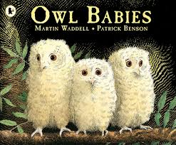  Funny Bones  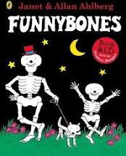  Rosies Walk  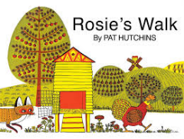 | Light and Dark / Celebrations  Whatever Next  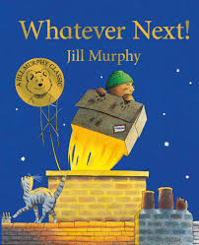  Lauras Star  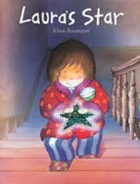  How to Catch a Star  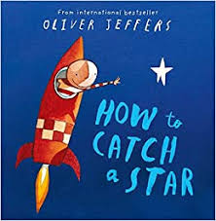  The Great Race  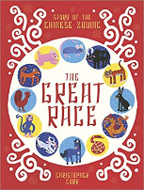 | Traditional Tales  Three Little Pigs / Billy Goats Gruff  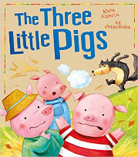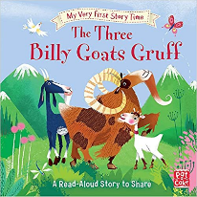  Going on a Bear Hunt / Gruffalo  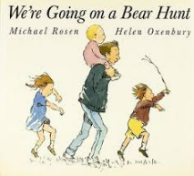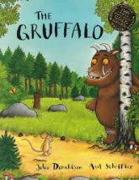  Little Red Riding Hood / Cinderella  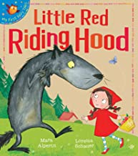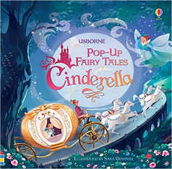  The Gingerbread Man / The Enormous Turnip  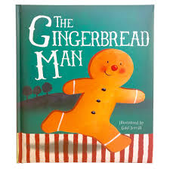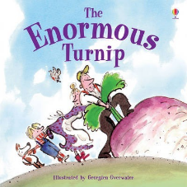 |  | On the Farm & Minibeasts  Farmer Duck  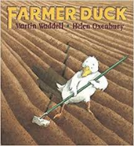  What the Ladybird Heard  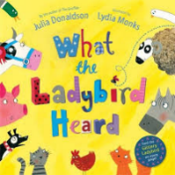  Hungry Caterpillar  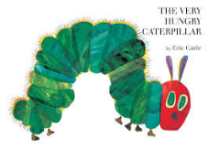  The Scarecrows Secret  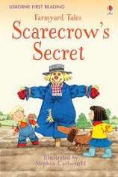 | Under the Sea  Tiddler  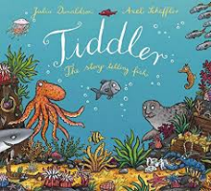  Rainbow Fish  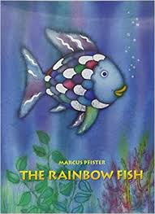  Commotion in the Ocean  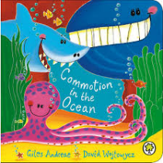  Shark in the Park  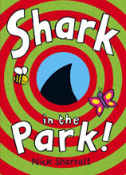
Reception Story time  (10 mins per day) | Elmer  Avocado Baby | Can’t you Sleep Little Bear?  The Owl Who was Afraid of the Dark | Handas Surprise  Each Peach, Pear, Plum  Over the Hills and Faraway |  | Superworm  Chicken Licken | The Snail and the Whale  Aliens Love Underpants
Year 1  Texts for Writing  Group Little Wandle Reading Sessions to take place three times a week. | Toys  Dogger  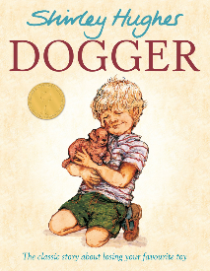  Toys in Space  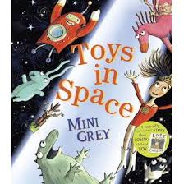 | Seasons  Seasons Come and Go Tree  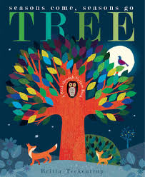  Out and About (Shirley Hughes Poems)  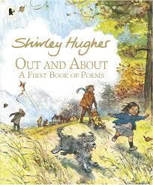 | People Who Help Us  Burglar Bill  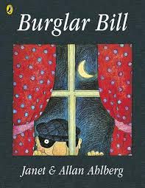  Lighthouse Keepers Lunch  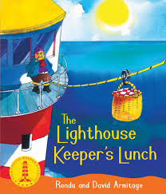 | Tamworth (Geography Focus)  Beegu  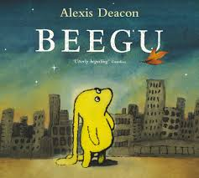Lila and the Secret of Rain  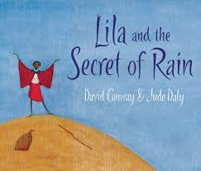 | Our Local Area (History)  In Every House on Every Street  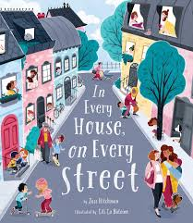The Tiger Who Came to Tea  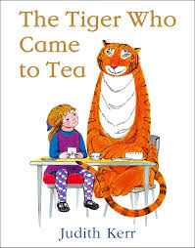  Herald  Tamworth Past and Present by John Harper  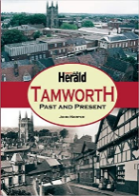 | All Around the World  The Penguin Who Wanted to Find Out  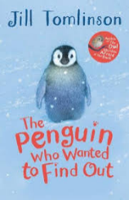  How to Wash a Woolly Mammoth  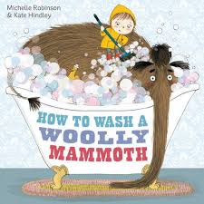
Year 1 Story time  (10 mins per day) | Would you Rather?  Not Now Bernard | Room on the Broom  Stickman | The Jolly Postman  Don’t Let the Pigeon Drive the Bus | I want my Hat Back  Hairy Maclary | Little Mouses Big Book of Fears  Where the Wild Things Are | Flat Stanley
Year 2  Texts for writing | Villages, Towns and Cities  Ziraffa Giraffa  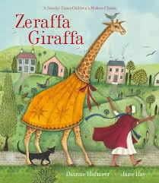  A Bear Called Paddington  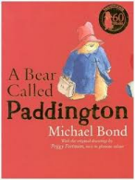  Paddington at the Palace  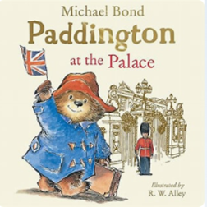 | Castles  Rapunzel  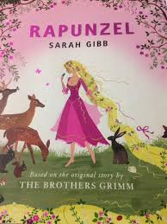  See Inside Castles  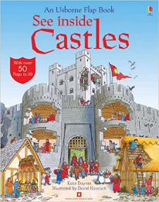 | Kenya  Nelson Mandela – Long Walk to Freedom  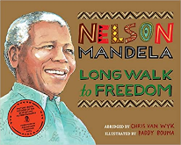  Meerkat Mail  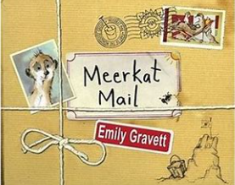 | Pioneering Women  Malala’s Magic Pencil  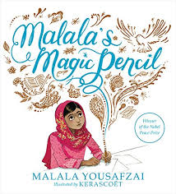  The Brontes: Children of the Moors  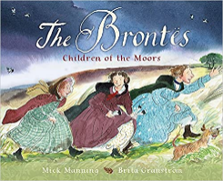 | At the Seaside  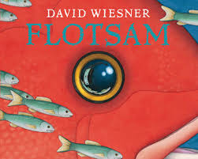  Flotsom  Poetry - The Seagulls – Kitt Kittlestand | The First Aeroplane Flight  The Glorious Flight: Across the Channel  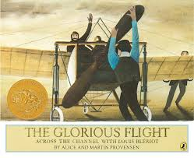  Amelia Earheart (National Geographic)  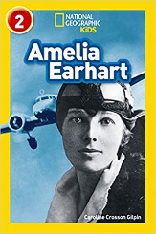
Year 2 Texts for Whole Class Reading | Katie in London  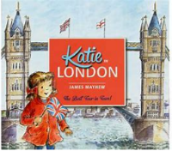 | The dragon Machine  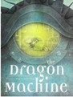 | 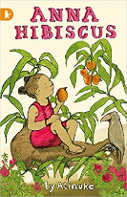  Anna Hibiscus
Year 2 Story time  (10 mins per day) | Fantastic Mr fox | The Sheep Pig | James and the Giant Peach | The Enchanted Wood | The Hodgeheg | The BFG
Year 3  Texts for Writing | Stone Age – Iron Age  Stone Age Boy & The Secrets of Stone Henge  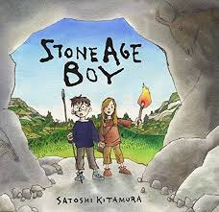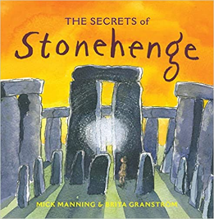 |  | Italy  King of the Sky  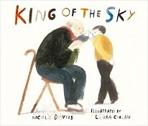 | The Romans  A Roman Adventure.  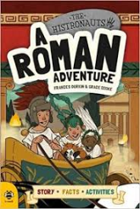  The Romans (Marcia Williams)  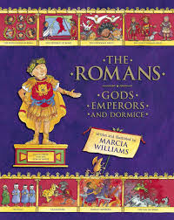 | Mountains, Volcanoes & Earthquakes  Escape from Pompeii  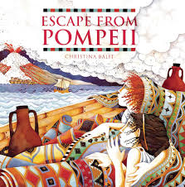  Everything Volcanoes and Earthquakes  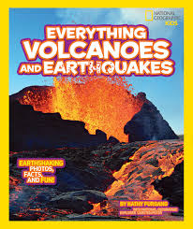 | The Ancient Maya  The Great Kapok Tree  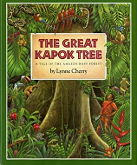  History Detectives: Mayan Civilisation  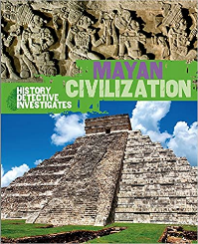
Texts for Whole Class Reading | 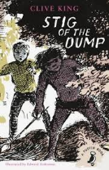  Stig of the Dump  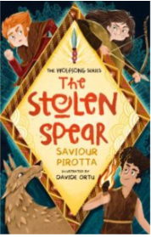  The Stolen Spear |  | 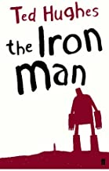  The Iron Man | 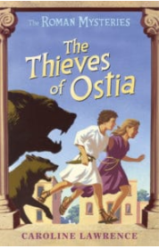  The Thieves of Ostia | 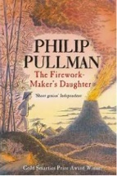  The Firework Makers Daughter | 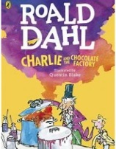  Charlie & The Chocolate Factory
Storytime  (10 mins per day) | The Legend of Podkin One Ear |  | The Borrowers | Gangsta Granny | King of the Cloud Forests | Charlie and the Chocolate Factory
Year 4  Texts for Writing | Rivers  A River (picture book)  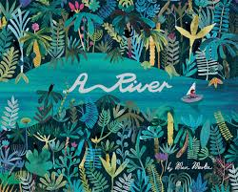  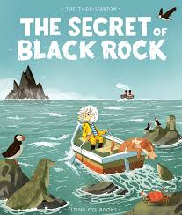  The Secret of Black Rock  Poetry – The Sea by James Reeves  Seaview Haiku – John Foster | Ancient Greeks  Usbourne Greek Myths  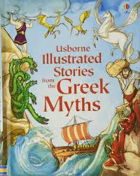  Mark of the Cyclops  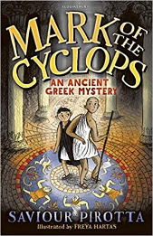 | America  The Miraculous Journey of Edward Tulane  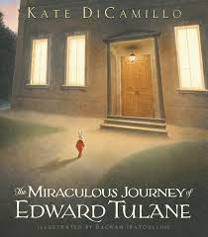  50 Adventures in the 50 States & National Parks of the USA  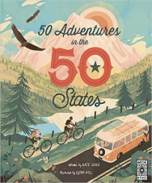  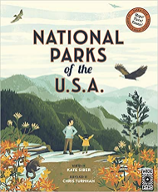 | Anglo Saxons  Anglo Saxon Boy  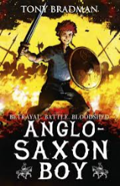  Beowolf  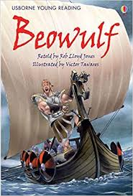 | Natural Resources  Greta’s Story – The Girl Who Went on Strike to Save the Planet.  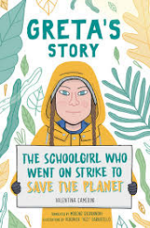  Town is by the Sea  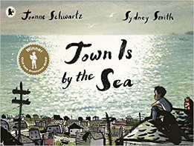 | Vikings  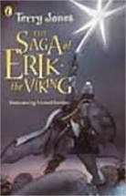  The Saga of Erik the Viking 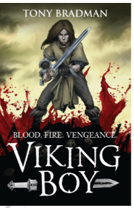  Viking Boy  Everything Vikings / The Viking Invader  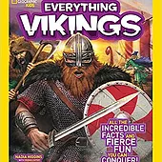  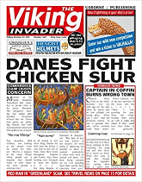
Year 4 Texts for Whole Class Reading | 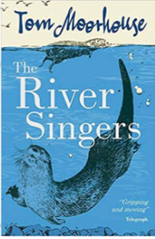  The River Singers | 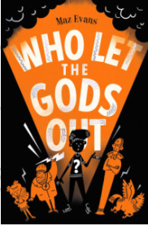  Who let the Gods out | 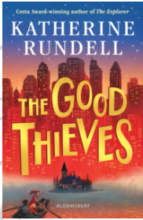  The Good Thieves | 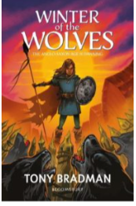  Winter of the Wolves | 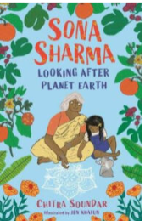Looking after Planet Earth | 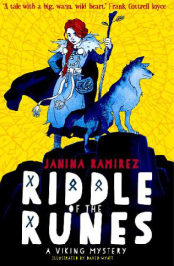 Riddle of the Runes
Year 4 Storytime  (10 mins per day) | The Witches  The Wind in the Willows | Who Let the Gods Out? | Varjak Paw | Harry Potter & the Philosophers Stone | Charlotte’s Web | How to Train Your Dragon
Year 5  Texts for Writing | Rainforests  Journey to River Sea  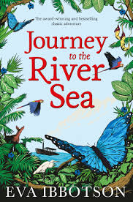  Wilderness: Earth's Amazing Habitats  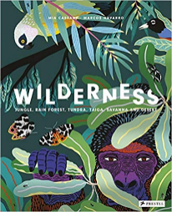  The Vanishing Rainforest  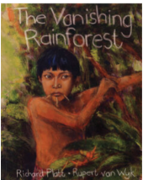 | Ancient Egypt  Egyptian Cinderella  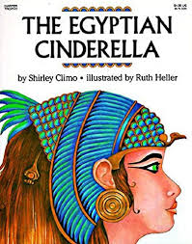  Ancient Egypt: Tales of Gods and Pharaohs  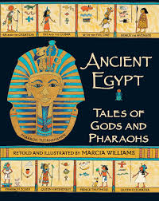 | Water, Weather and Climate  The Extraordinary Colours of Auden Dare  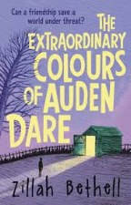  Climate Crisis for Beginners  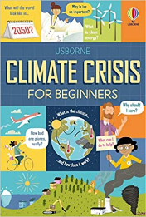  Flood  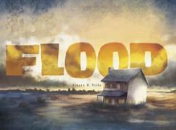  The Dam  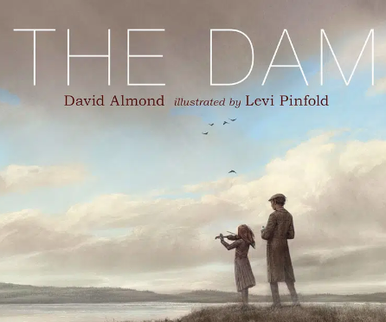 | The Norman Invasion  Outlaw – The True Story of Robin Hood  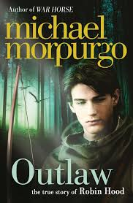  Explore Normans  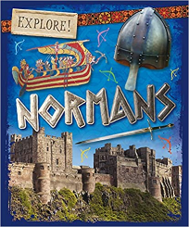 | Energy & Sustainability  Kensukes Kingom  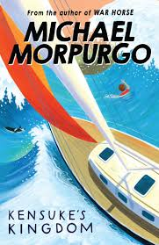  Guardians of the Planet  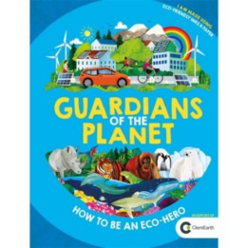  The Moose belongs to me  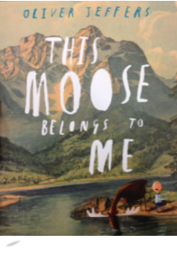 | The Great Plague  The Children of Winter  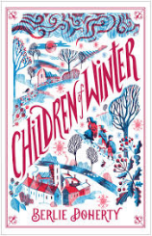
Year 5  Texts for Whole Class Reading | 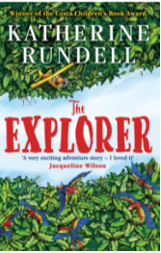  The Explorer | 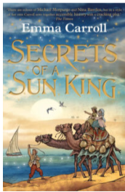  Secrets of a Sun King | 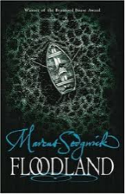  Floodland |  | 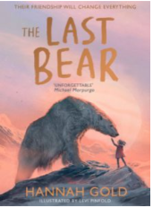  The Last Bear | 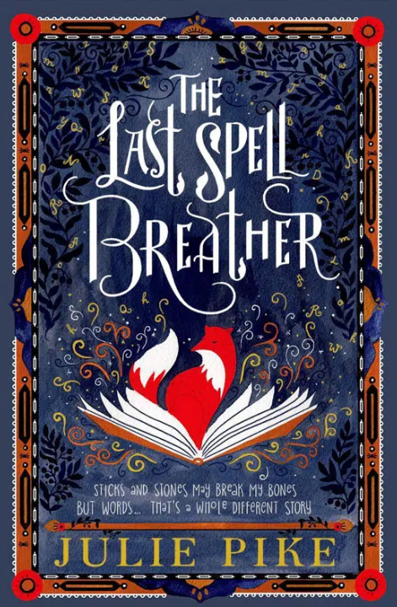  The Last Spell Breather
Storytime  (10 mins per day) | Running Wild by Michael Morpurgo | The Lion, the Witch and the Wardrobe | Cosmic | The Demon Dentist | The Secret Garden | The Nowhere Emporium
Year 6  Texts for Writing | Mexico  Holes  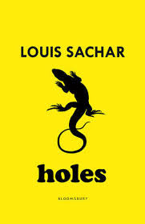 | The Victorians  Street Child  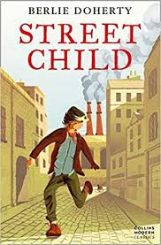  The Highway Man  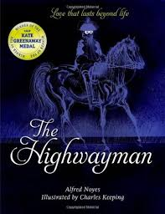 | Globalisation and Fair Trade  Amazing Evolution: The Journey of Life (Link to Science)  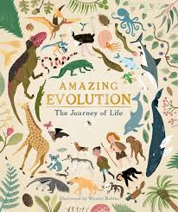  The Giants’ Necklace  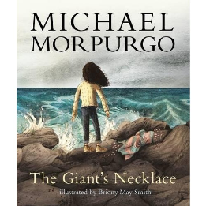 | World War 2  Letters From the Lighthouse  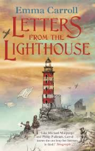  Otto Biography of a Bear  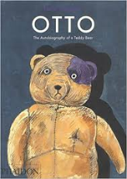  Where the Poppies now Grow  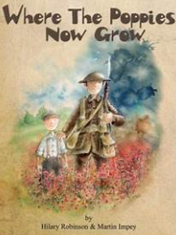 |  | Local Fieldwork Study  Skellig  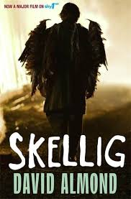  The Island (picture book).  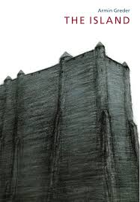
Year 6  Texts for Whole Class Reading | 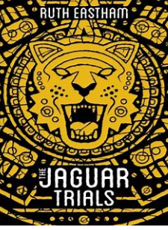  The Jaguar Trials | 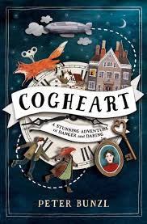  Cogheart | 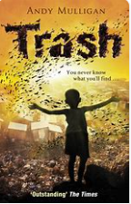  Trash | 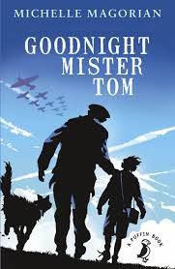  Goodnight Mr Tom or The Emergency Zoo |  | 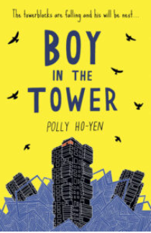  The Boy in the Tower
Year 6  Storytime  (10 mins per day) | A Pinch of Magic | Another Twist in the Tale | Tom’s Midnight Garden | When Hitler Stole Pink Rabbit |  | Wonder

